

**COURSE NAME :** DIGITAL MARKETING  
**GROUP NUMBER** : 08

**PROJECT TITLE** : Creating A Google Ads Campaign For Your Brand

**SUBMITTED TO** : ANNA UNIVERSITY / NAANMUTHALVAN

**YEAR** : 2023

**DEPARTMENT** : HANDLOOM AND TEXTILE TECHNOLOGY

**SEMESTER** : 7TH SEMESTER  
**GROUP MEMBERS** : GAJAM MANASA

DASARI GANESH

GALI SUNIL KUMAR

GIRIJA.V

**GUIDED BY** : S BABUPRIYA AP/ MANAGEMENT STUDIES

**SPOC NAME** : DR.C.PRABAKARAN ,SENIOR LECTURE IN

TEXTILE

|  |  |  |  |
| --- | --- | --- | --- |
| **S.NO**  **1.**  **2.**  **3.**  **4.**  **5.**  **6.**  **7.**  **8.**  **9.**  **10.** | **TABLE CONTENT**  **Abstract**  **Introduction**  **Objective**  **What is Google ads campaign**  **Why Google ads campaign needs**  **Types of Google ads**  **How to create a Google ads campaign for your brand**  **Advantages**  **Applications**  **Conclusion.** |  |  |

**1.ABSTRACT**

Google Ads, a pivotal component of online advertising, is a platform developed by Google that enables businesses to create and display ads on Google's extensive network of search engines and partner websites. Advertisers select keywords and set bids, competing in an auction-based system to have their ads displayed when users search for those keywords.

The quality of ads, measured by a Quality Score, influences placement and costs. Advertisers have control over budget, employ ad extensions for additional information, and utilize a range of targeting options for specific audiences. Conversion tracking and detailed analytics help assess campaign performance. Ad Rank, a combination of bid, ad quality, and expected click-through rate, determines ad position. Advertisers pay based on the Cost-Per-Click (CPC).

Google Ads is a versatile tool for businesses to reach and engage with potential customers online while adhering to strict ad policies.

**INTRODUCTION**

A Google Ads campaign is a powerful online advertising strategy developed by Google, allowing businesses and advertisers to promote their products, services, or brand on the world's most popular search engine. This advertising platform, formerly known as Google AdWords, is a pay-per-click (PPC) system, which means advertisers pay only when users click on their ads. Google Ads provides a dynamic and flexible way to reach a broad and highly targeted audience, making it an essential tool for businesses looking to establish a digital presence and drive online success.

In a Google Ads campaign, advertisers bid on specific keywords or phrases related to their products or services. When a user enters a search query that matches these keywords, Google displays the advertiser's ads on the search results page, typically at the top and bottom of the page. This enables businesses to connect with potential customers precisely when they are actively searching for products or information, making it a highly efficient and measurable form of advertising.

The key elements of a Google Ads campaign include setting a budget, defining target audiences, creating compelling ad copy, and selecting bidding strategies. Advertisers can also choose from various campaign types, such as Search, Display, Video, Shopping, and more, each tailored to specific advertising goals.

Monitoring and analyzing the performance of a Google Ads campaign is crucial for optimizing results. Advertisers can track various metrics, including click-through rates, conversion rates, and return on investment (ROI) to fine-tune their strategies and achieve the best possible outcomes.

Google Ads offers a wide range of tools and features to help advertisers maximize the impact of their campaigns, making it a go-to platform for businesses looking to boost their online presence, attract customers, and grow their revenue. It's a dynamic and ever-evolving advertising system that continues to be a cornerstone of digital marketing strategies.

**3.OBJECTIVE**

The objectives of a Google Ads campaign can vary significantly depending on the goals of the advertiser. When setting up a Google Ads campaign, it's essential to establish clear and specific objectives that align with your overall business and marketing goals. Here are some common objectives for running a Google Ads campaign:

1. Increase Website Traffic: Drive more visitors to your website to increase brand exposure and provide potential customers with information about your products or services.

2. Generate Leads: Encourage users to submit contact information or sign up for newsletters, webinars, or other lead generation forms.

3.Boost Sales: Drive online sales of products or services directly through your website or e-commerce platform.

4.Raise Brand Awareness: Increase the visibility of your brand or product to a broader audience and improve brand recognition.

5.Promote Local Business: Attract local customers to physical storefronts by promoting location-specific ads and special offers.

6.Expand Reach: Reach a wider audience by showing your ads on the Google Display Network, which includes millions of websites and apps.

7.Product Showcase: Use Google Shopping campaigns to showcase your products and reach users actively looking to make a purchase.

8. App Installations: Promote app downloads for mobile applications and encourage users to install and engage with your app.

9.Video Views: Increase the number of views on your video content, such as YouTube videos, to promote your brand or deliver a specific message.

10.Conversion Rate Improvement: Focus on optimizing your ad campaigns to increase the percentage of users who take a specific desired action, such as making a purchase, filling out a form, or contacting your business.

11.Cost Reduction: Lower the cost per click (CPC) or cost per conversion while maintaining or improving the campaign's performance.

12.Competitive Edge: Outperform competitors in the online advertising space by targeting the same audience with more effective ad campaigns.

13.Seasonal or Promotional Campaigns: Create short-term campaigns to promote seasonal offers, special discounts, or limited-time promotions.

14.Remarketing: Re-engage with users who have previously visited your website or interacted with your brand to encourage them to take further action.

15. Educational Content: Share informative content to establish authority in your industry and educate potential customers about your products or services.

16.Event Promotion: Use Google Ads to promote events, such as webinars, seminars, workshops, or product launches.

17.Social Impact: Support social causes or raise awareness for issues by using Google Ads as a platform for public service announcements and charitable campaigns.

18.Market Research: Test different ad copy, landing pages, or audience targeting to gather data and insights that can be used to inform broader marketing strategies.

It's crucial to set measurable key performance indicators (KPIs) and regularly track the progress of your Google Ads campaign to ensure that you're meeting your objectives. The choice of objectives should align with your business goals and be adaptable to changing market conditions and consumer behavior.

**5. WHAT IS GOOGLE ADS CAMPAIGN**

A Google Ads campaign is a structured and organized effort to advertise products, services, or content on Google's advertising platform. It allows businesses and advertisers to promote their offerings through paid ads that appear in Google search results and across Google's vast network of partner websites and platforms. Google Ads campaigns are designed to achieve specific advertising objectives and are composed of the following key components:

1.Campaign Type: Advertisers choose the type of campaign that best aligns with their goals. Google Ads offers various campaign types, including Search, Display, Video, Shopping, App, and more. Each type serves different purposes and targets different audience segments.

2.Ad Groups: Within a campaign, advertisers create ad groups, each focusing on a particular set of keywords, products, or themes. Ad groups help organize ads and ensure that they are closely related to the search queries and user intent.

3. Keywords: Advertisers select relevant keywords that trigger their ads to appear when users search on Google. These keywords are crucial in determining when and where ads will be shown.

4. Ad Creatives: Ad creatives include ad headlines, descriptions, and display URLs. Advertisers write compelling and relevant ad copy to attract users and encourage them to click on the ad.

5. Bidding Strategy: Advertisers set a bidding strategy to determine how much they are willing to pay for each click or specific action, like a conversion. Bidding strategies can be manual or automated and can be tailored to meet budget and performance goals.

6.Targeting: Advertisers define the target audience for their campaign, specifying location, demographics, interests, and other parameters to ensure that ads reach the right users.

7.Budget: Advertisers set a daily or monthly budget to control their ad spend. Google will not exceed this budget, helping advertisers manage their expenses effectively.

8.Ad Extensions: These are additional pieces of information that can be added to ads to provide more context and entice users to click. Common ad extensions include site link extensions, callout extensions, and location extensions.

9.Quality Score: Google assigns a quality score to ads and keywords, which evaluates the relevance and quality of the ad and its landing page. A higher-quality score can lead to better ad placements and lower costs.

10.Conversion Tracking: Advertisers implement conversion tracking to measure the success of their campaign in terms of actions taken by users, such as purchases, form submissions, or phone calls.

11.Ad Scheduling: Advertisers can specify the days and times when their ads should appear, optimizing ad delivery to coincide with peak user activity or specific business hours.

12.Ad Rotation: This feature allows advertisers to control the rotation of their ads to evenly distribute impressions among different ad variations, such as split-testing different ad copies.

Google Ads campaigns are dynamic and adaptable, allowing advertisers to fine-tune their strategies and objectives based on performance data and changes in the market. The platform offers robust reporting and analytics tools to track the success of campaigns and make informed decisions for optimization. Successful Google Ads campaigns can drive targeted traffic, generate leads, increase sales, and boost brand visibility, making it a valuable tool for digital marketing and advertising.

**6.WHY GOOGLE ADS CAMPAIGN NEEDS**

There are several reasons why a Google Ads campaign is necessary for businesses:

1. Increased visibility: Google is the most popular search engine, with billions of searches conducted every day. By running a Google Ads campaign, businesses can ensure that their ads appear prominently in search results, increasing their visibility to potential customers.

2. Targeted advertising: Google Ads allows businesses to target specific keywords, demographics, locations, and interests. This enables businesses to reach their ideal audience and deliver tailored ads to those who are most likely to be interested in their products or services.

3. Cost-effective: Google Ads operates on a pay-per-click (PPC) model, meaning businesses only pay when someone clicks on their ad. This makes it a cost-effective advertising option, as businesses can set their own budget and control their spending.

4. Measurable results: Google Ads provides detailed analytics and reporting, allowing businesses to track the performance of their campaigns. This includes information on impressions, clicks, conversions, and return on investment (ROI), enabling businesses to make data-driven decisions and optimize their campaigns for better results.

5. Flexibility and control: Google Ads offers businesses flexibility in terms of ad formats, ad scheduling, and targeting options. Businesses can customize their campaigns to suit their specific goals and adjust them as needed to achieve the desired outcomes.

6. Competitive advantage: Running a Google Ads campaign allows businesses to compete with larger competitors and gain a competitive edge. It provides an opportunity for businesses to appear alongside or above organic search results, increasing their chances of attracting potential customers.

Overall, a Google Ads campaign is essential for businesses looking to increase their online visibility, reach their target audience, and drive relevant traffic to their website or landing pages.

.

**7.TYPES OF GOOGLE ADS CAMPAIGN**

**1: Responsive Search Ads (RSAs)**

**2: Dynamic Search Ads (DSAs)**

**3: Display Ads**

**4: App Promotion Ads**

**5: Video Ads**

**6: Shopping Ads**

**7: Local Search Ads**

**8: Call-Only Ads**

**9: Local Service Ads**

**8.HOW TO CREATE A GOOGLE ADS CAMPAIGN FOR YOUR BRAND**

**1: Search google ads**

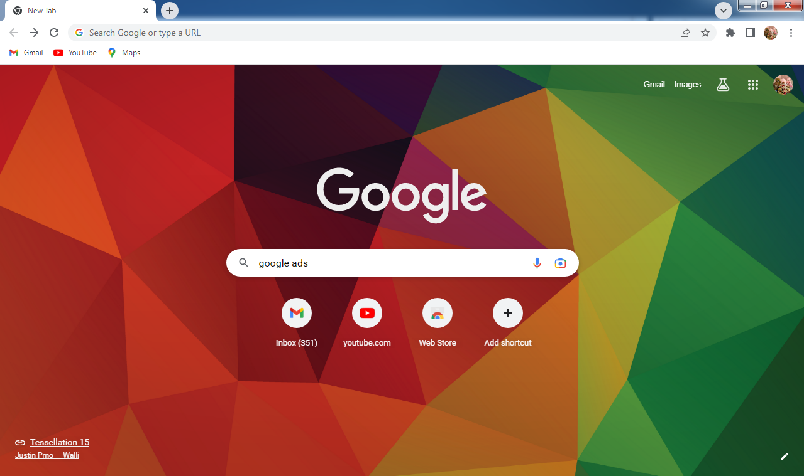

**2: Select google ads**

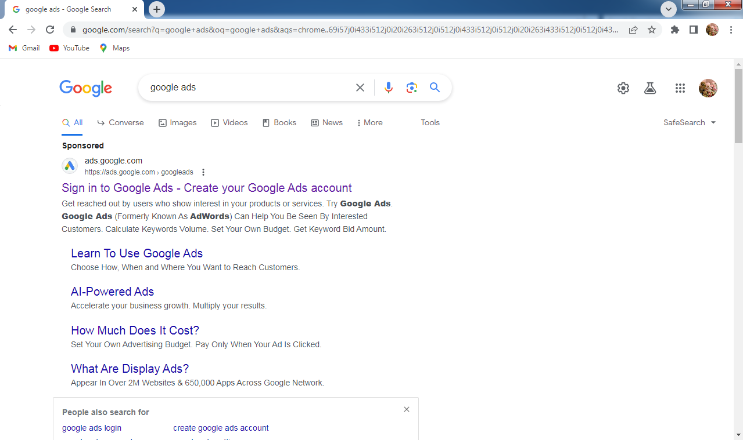

**3: Sign up**

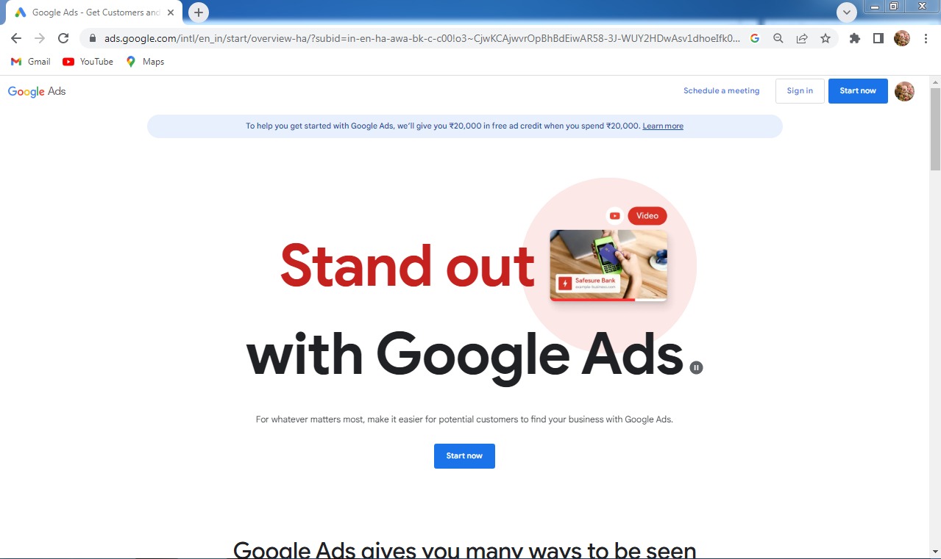

**4: New campaign**

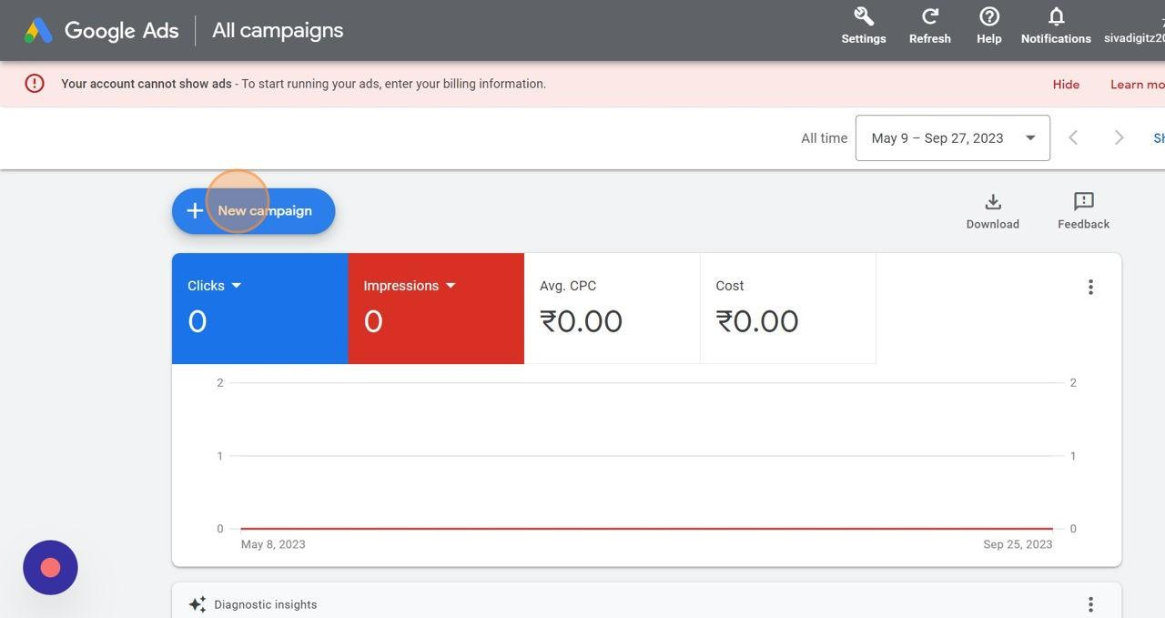

**5: Campaign objective**

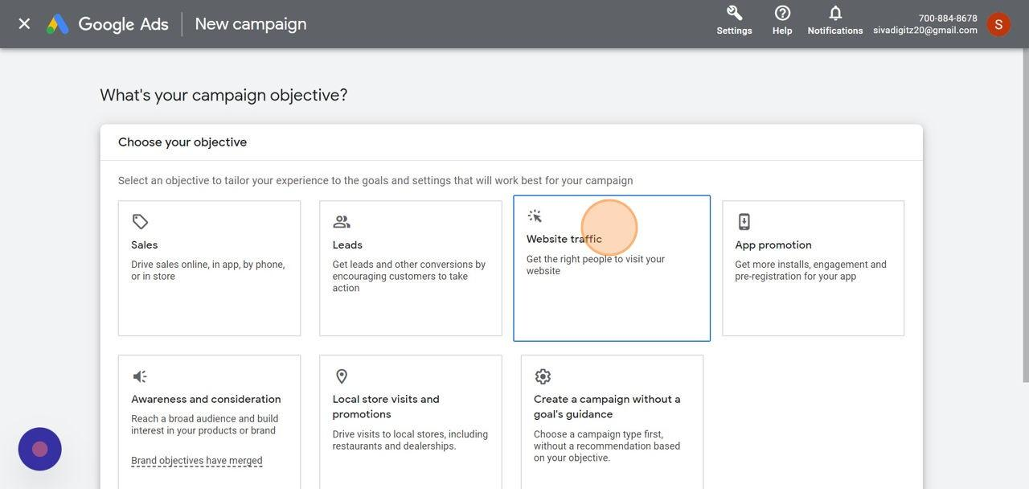

**6:CAMPAIGN TYPE**

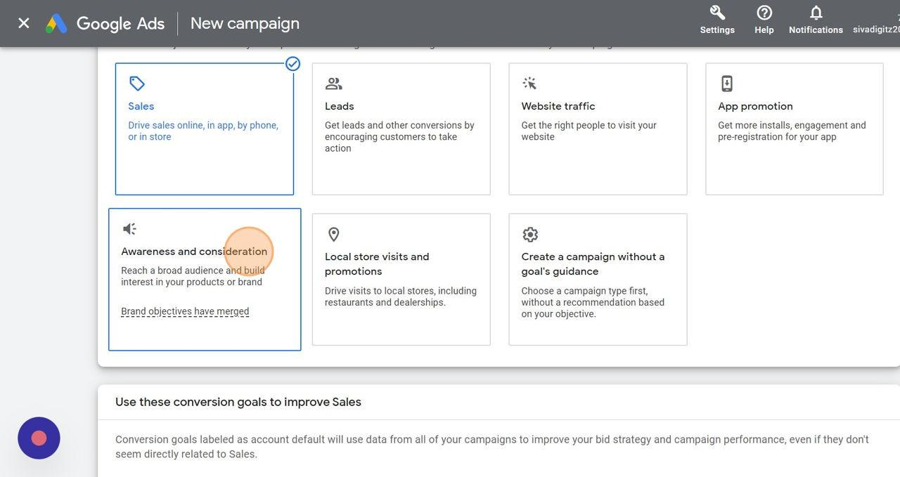

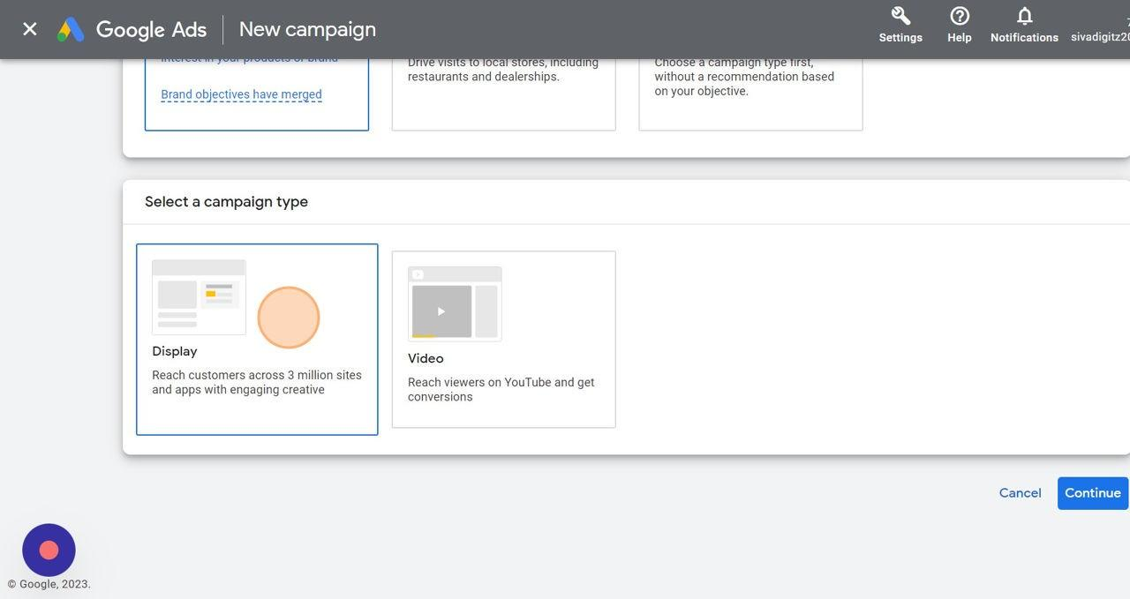

**7 : WEBSITE AND CAMPAIGN NAME**

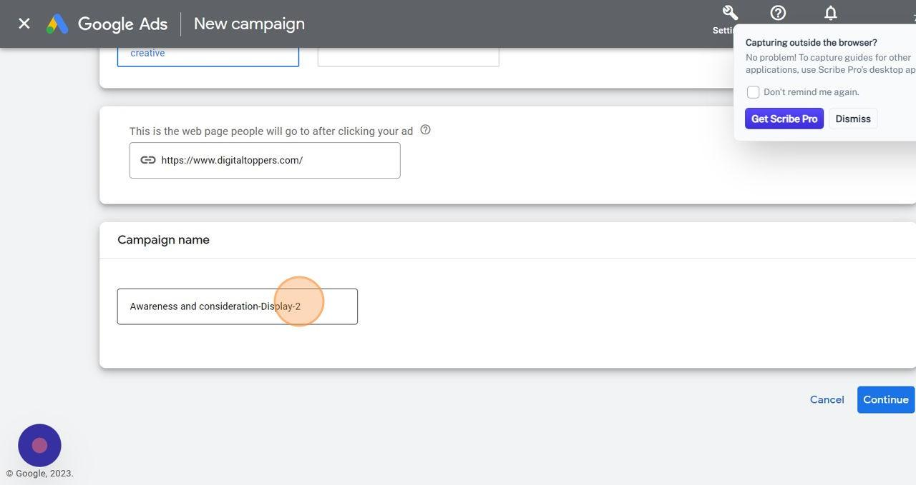

**8 : LOCATION AND LANGUAGES**

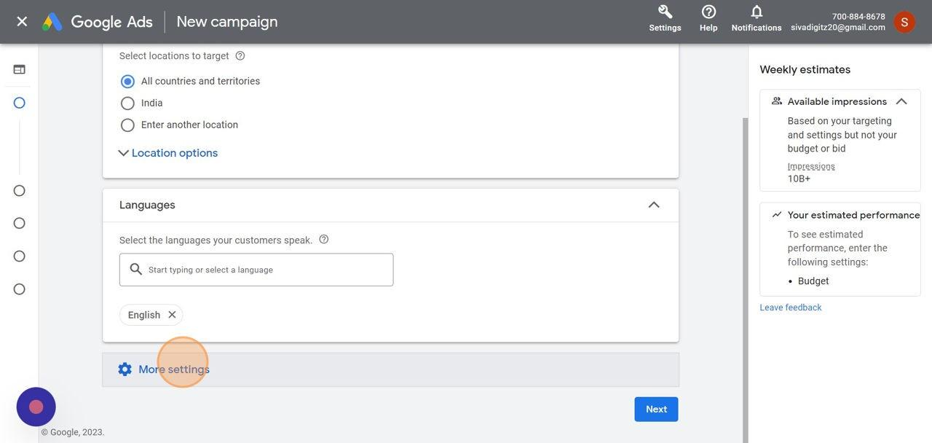

**9 : MORE SETTINGS-Ad SCHEDULE,Ad DURATION**

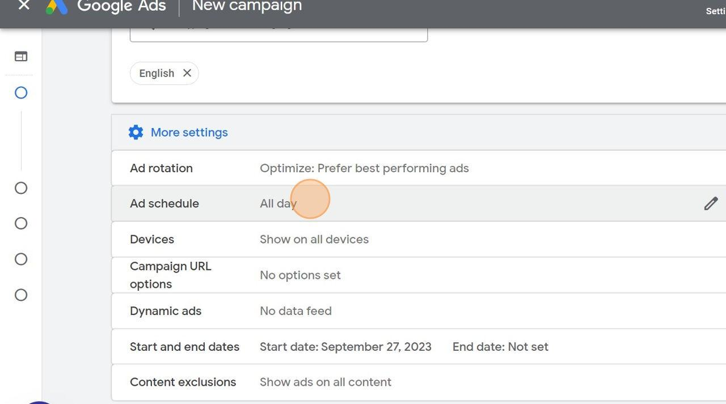

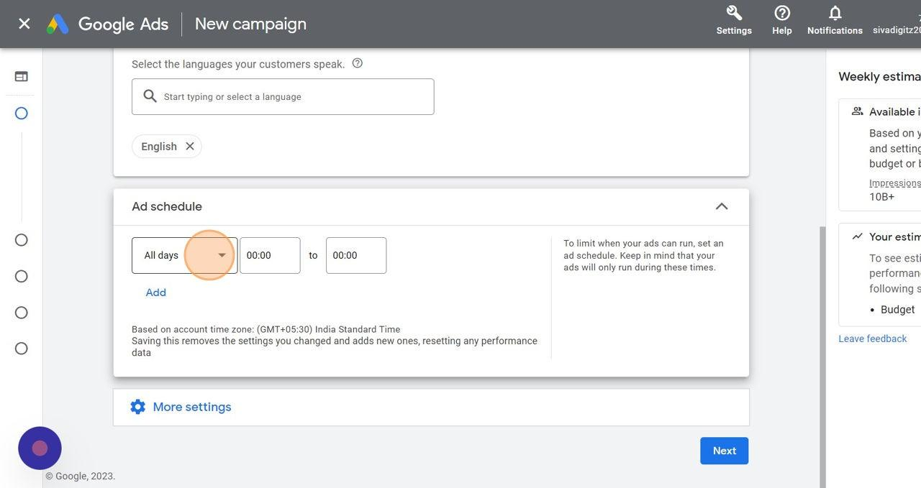

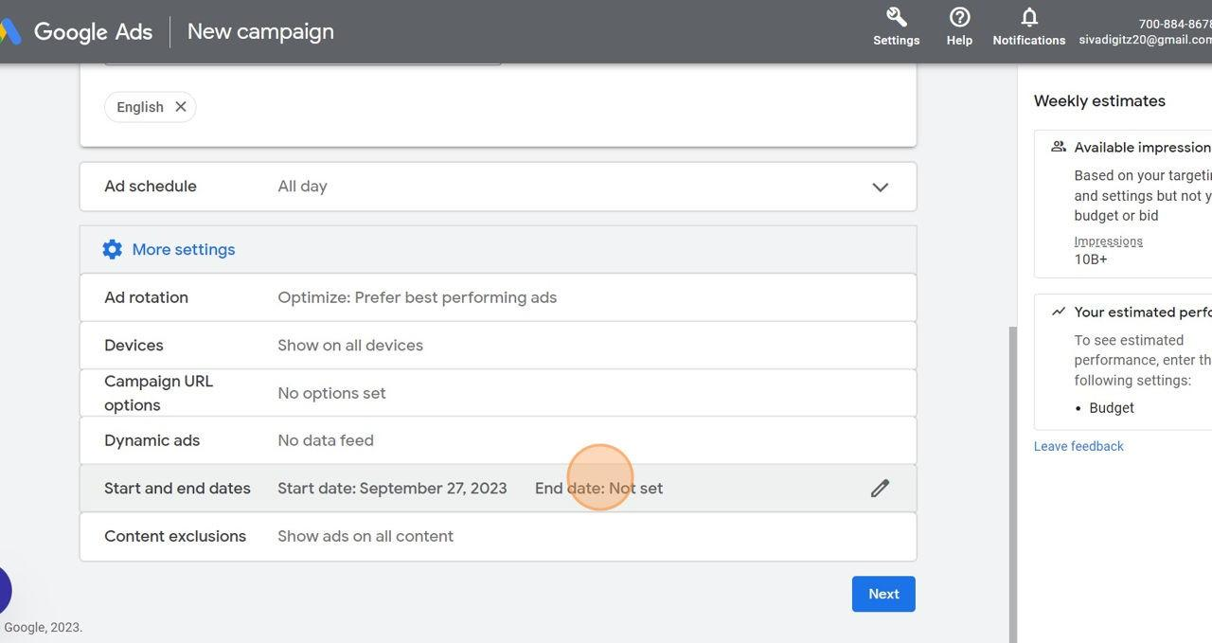

**10 :Ad BUDJET**

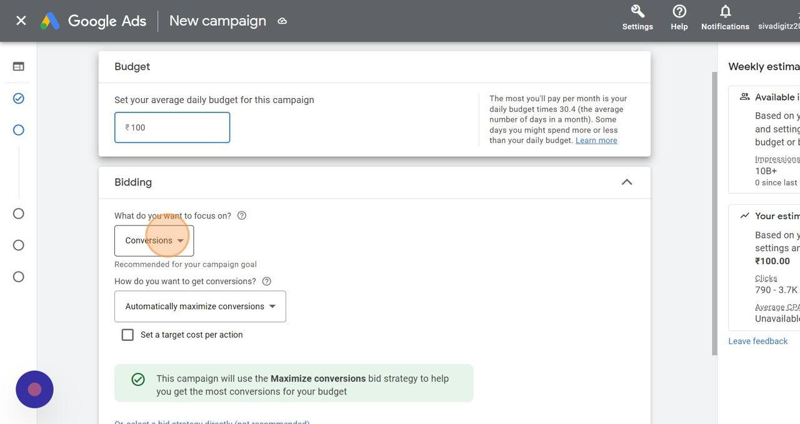

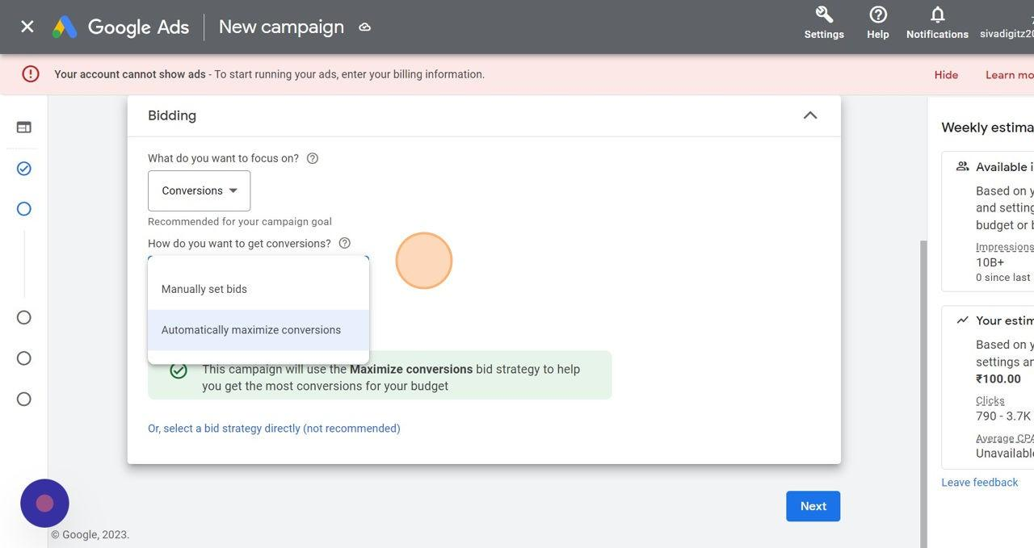

**11 :Ad TARGETING**

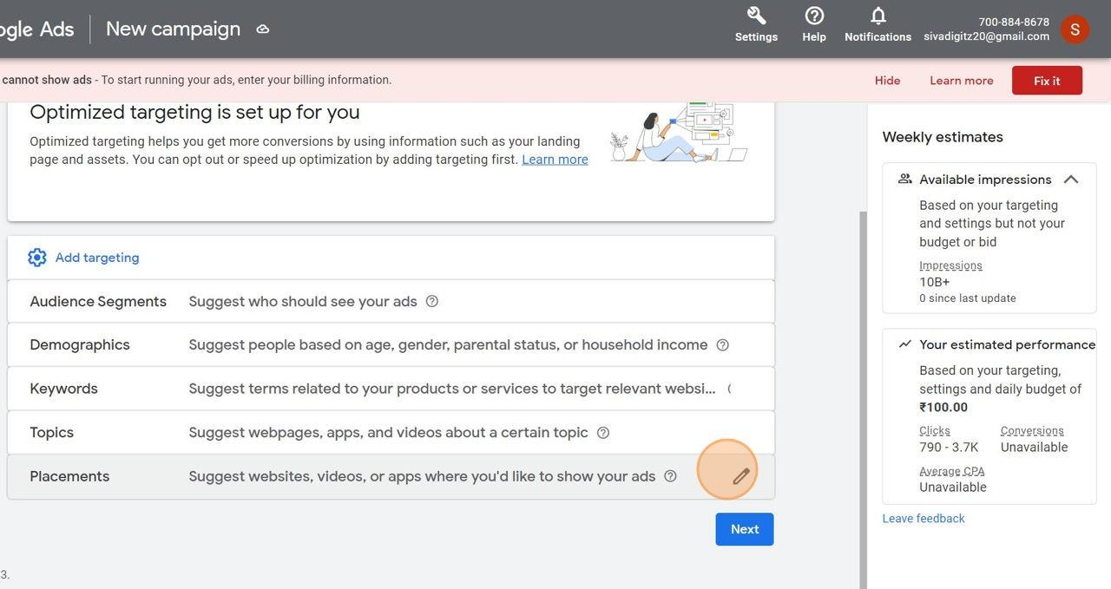

**12 :AUDENCE,DEMOGRAPHICS**

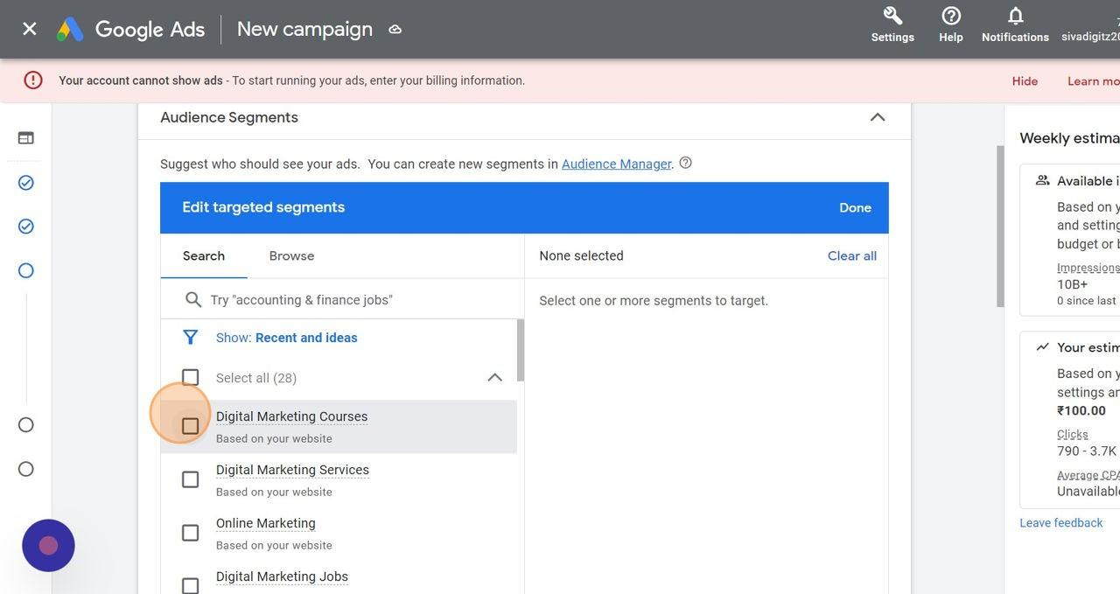

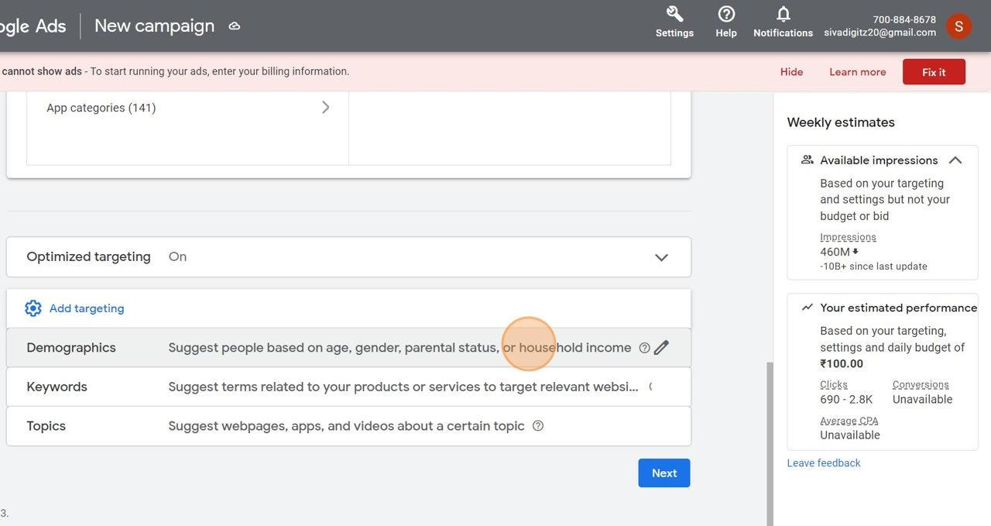

**13 : KEYWORDS AND TOPICS**

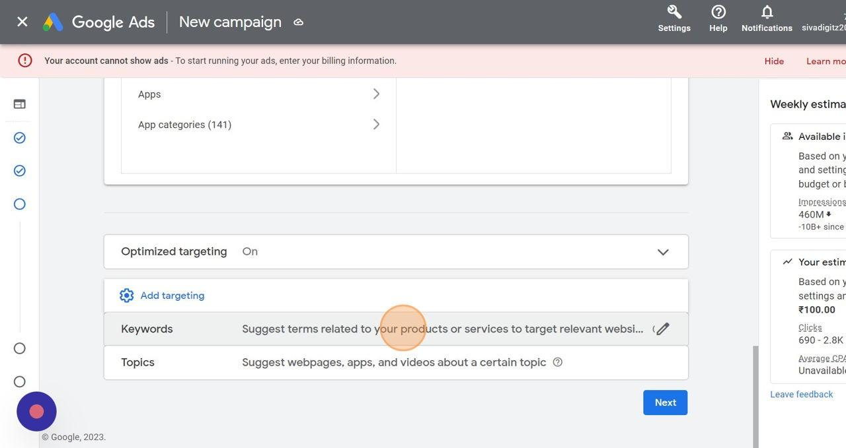

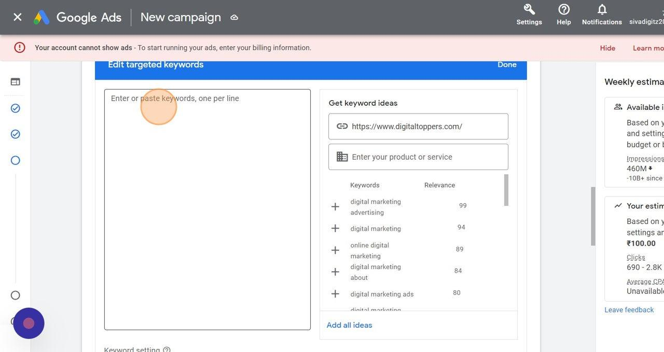

**14 : BUSINESS NAME,IMAGES,LOGO**

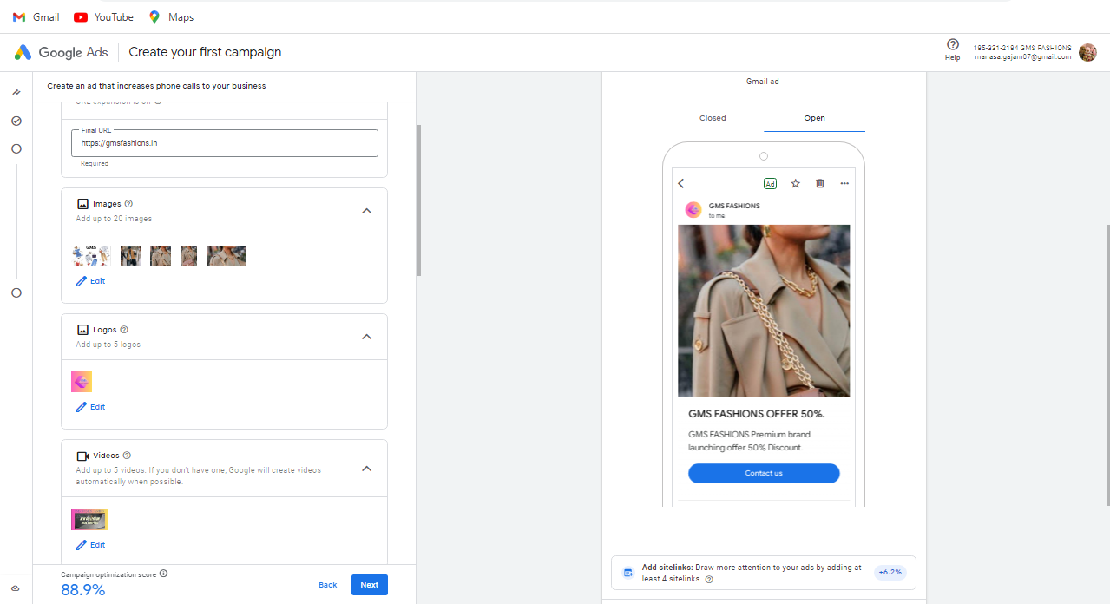

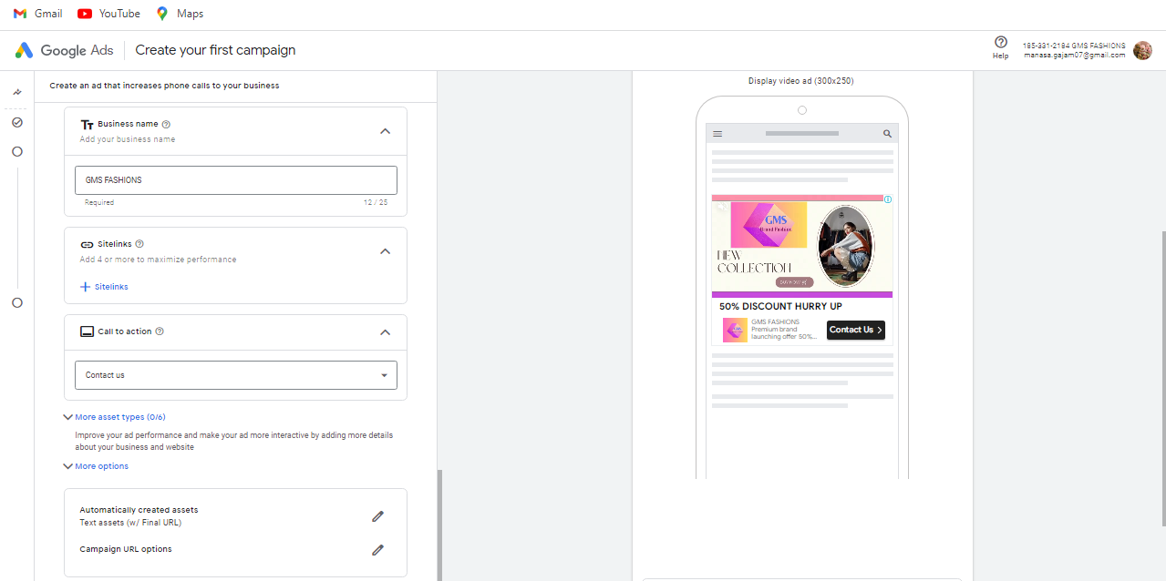

**15 : VIDEOS**

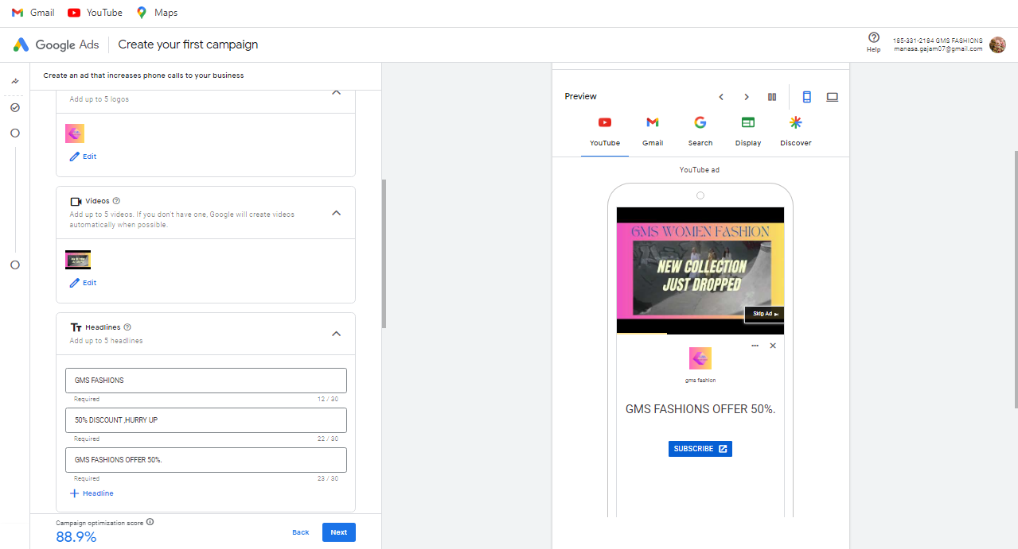

**16 : HEADLINES AND DESCRIPTION**

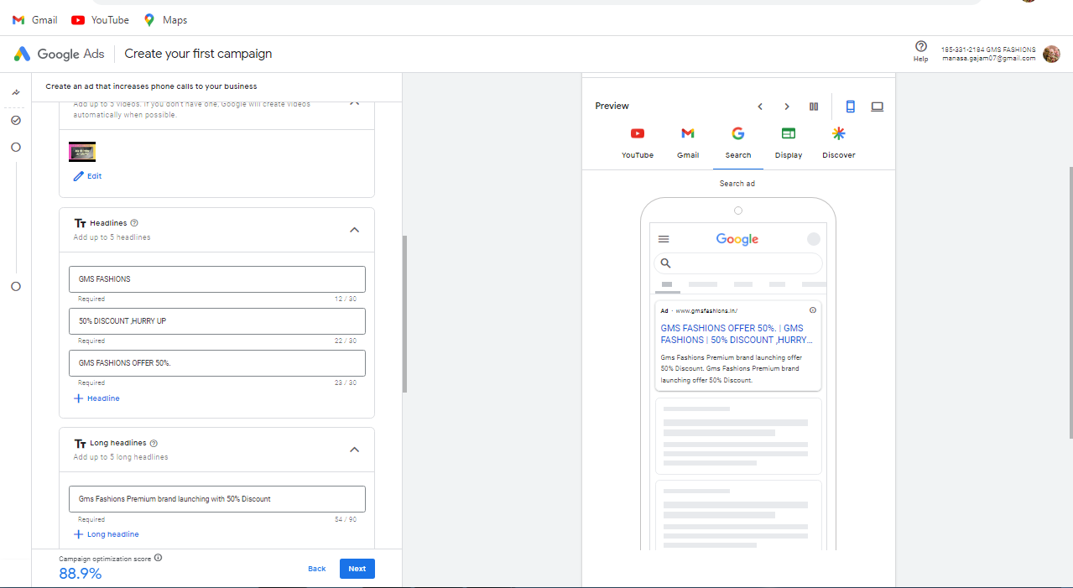

**17 : PUBLISH CAMPAIGN**

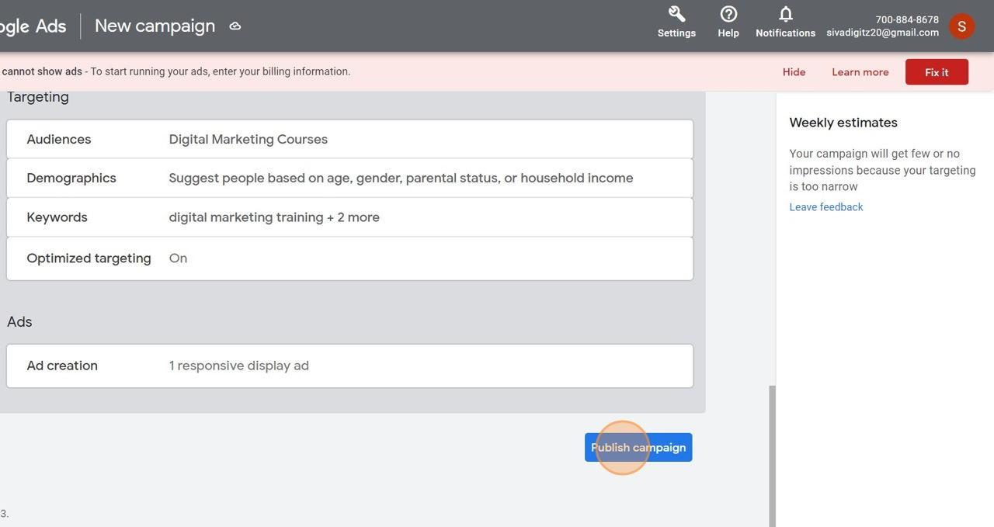

**8. ADVANTAGES**

Google Ads offers several advantages for businesses looking to promote their products or services online.

1. Targeted Advertising: You can reach a highly specific audience based on factors like location, demographics, keywords, and user interests, ensuring that your ads are seen by those most likely to be interested in your offerings.

2. Cost Control: Google Ads allows you to set a budget for your advertising campaigns, and you only pay when someone clicks on your ad (Pay-Per-Click or PPC). This enables you to control costs effectively.

3. Quick Results: Unlike many traditional advertising methods, Google Ads can start driving traffic and results within hours of setup.

4. Measurable Results: Google Ads provides detailed metrics and analytics, so you can track the performance of your campaigns, including clicks, conversions, and return on investment (ROI).

5. Flexibility: You can easily adjust your ad campaigns, targeting, and budget to optimize performance based on real-time data and insights.

6. Ad Extensions: You can enhance your ads with extensions like site links, callouts, and structured snippets, providing additional information to potential customers.

7. Ad Formats: Google Ads supports various ad formats, including text ads, image ads, video ads, and shopping ads, allowing you to choose the most suitable format for your goals.

8. Competitive Advantage: If used effectively, Google Ads can help you outperform competitors by appearing at the top of search results for relevant keywords.

9. Remarketing: You can target users who have previously visited your website but didn't convert, giving you another opportunity to engage with potential customers.

10. Global Reach: Google Ads allows you to reach a global audience, making it suitable for businesses of all sizes, from local shops to multinational corporations.

11. Mobile-Friendly: With a large portion of internet users accessing content on mobile devices, Google Ads is optimized for mobile advertising.

12. Ad Scheduling: You can control when your ads are displayed, ensuring that they are shown at the most effective times for your target audience.

Overall, Google Ads can be a powerful tool for businesses to increase their online visibility, attract potential customers, and achieve their marketing objectives.

**9. APPLICATIONS**

Some potential ways to apply these Google Ads campaigns to your brand could include:

* For the Influencer Partnership Campaign, identify influencers in your industry who have a large and engaged following. Collaborate with them to create content that promotes your brand or products, and leverage their credibility to increase awareness and drive sales
* The Customer Retention Campaign can be used to target existing customers with personalized ads and offers. Show appreciation for their support by offering exclusive discounts or rewards, encouraging repeat purchases and fostering loyalty
* Utilize the Social Media Advertising Campaign to extend your reach beyond Google by running ads on popular social media platforms. Use the targeting options available on these platforms to reach specific demographics or interests that align with your brand.
* Expand your ad reach by utilizing the Display Network Campaign. Display visually appealing banner ads on websites within the Google Display Network to capture the attention of users browsing their favorite websites.
* Promote your mobile app through the App Install Campaign. Create campaigns that focus on driving app installs and engagement, utilizing app-specific ad formats and targeting options to reach users who are more likely to download and use your app.
* Implement a Dynamic Remarketing Campaign to display personalized ads that showcase products or services that users have previously shown interest in. Use dynamic ad templates to automatically update your ads based on users' browsing behavior.
* Consider a Competitor Targeting Campaign to target users who are searching for or visiting your competitors' websites. Highlight the unique features and benefits of your brand or products to convince them to choose you over the competition.
* Utilize a Cross-Sell or Upsell Campaign to promote related products or upgrades to existing customers based on their previous purchases or browsing behavior. Encourage them to explore additional offerings and increase their overall spend.
* Integrate your Google Ads campaigns with your email marketing efforts for a cohesive customer journey. Use targeted ads to reinforce the messaging and offers sent through email.
* Implement a Brand Reputation Management Campaign by monitoring and responding to online reviews and comments about your brand. Use targeted ads to address any negative feedback or showcase positive testimonials to maintain a positive brand image.

**GOOGLE ADS CAMPAIGN URL**

YOUTUBE URL - <https://youtu.be/jT9qCEcxEuo?feature=shared>

GOOGLE ADS PAGE URL - <https://gmsfashions.in>

**10.CONCLUSION**

The Google Ads campaign should involve analyzing the campaign's performance, understanding key metrics like click-through rates, conversion rates, and return on investment, and making data-driven decisions to optimize and refine your ad strategy for better results. It's an ongoing process that requires continuous monitoring and adjustments to meet your advertising goals effectively.

Google Ads is a powerful advertising platform that helps businesses reach their target audience and achieve their advertising goals. Whether you're looking to increase website traffic, leads, or sales, Google Ads offers a variety of tools and features to help you create effective campaigns.

Google Ads is a highly effective advertising platform that offers businesses numerous benefits. It allows businesses to reach a large audience, target specific demographics, and track the performance of their ads in real-time. Google Ads also provides various ad formats and customization options, enabling businesses to create engaging and visually appealing advertisements. Additionally, the platform offers a flexible budgeting system, allowing businesses of all sizes to allocate their advertising spend effectively. Overall, Google Ads is a valuable tool for businesses looking to increase their online visibility, drive traffic to their websites, and generate leads or sales.

----------------------------------------------------------------------------------